Research Architecture Specification
Project: Hybrid Explainable Heterogeneous Graph Anomaly Detection for Healthcare Provider Fraud Detection
Dataset: CMS Healthcare Provider Fraud Detection Analysis (Kaggle / CMS LDS derivative)
Target unit of prediction: Provider (PotentialFraud)
Recommended stack: Heterogeneous graph → R-GCN / GraphSAGE → dual-head (supervised + anomaly) → fusion → GNNExplainer audit

1. System Architecture Diagram Description
Purpose
End-to-end pipeline from raw CMS CSV files to fraud predictions and explainable subgraph reports for auditors.
Layered architecture (top → bottom)
Layer | Name | Responsibility
L1 | Data Ingestion Layer | Load Train/Test CSVs (providers, beneficiaries, inpatient/outpatient claims)
L2 | Preprocessing & Feature Engineering Layer | Clean, encode, aggregate claim-level statistics to entity-level features
L3 | Graph Construction Layer | Build heterogeneous graph G = (V, E, τ, φ) with typed nodes and edges
L4 | Hybrid Detection Layer | R-GCN encoder → supervised classifier + Isolation Forest on embeddings → score fusion
L5 | Explainability Layer | GNNExplainer on flagged provider ego-subgraphs; fidelity scoring
L6 | Evaluation & Reporting Layer | CV metrics, baselines, ablations, case-study exports
Publication figure caption (suggested)
Figure 1. System architecture of the proposed hybrid explainable heterogeneous graph anomaly detection framework for Medicare provider fraud. Raw CMS claims are transformed into a heterogeneous provider graph, encoded by an R-GCN, scored by parallel supervised and unsupervised heads, fused into a final fraud risk score, and explained via subgraph attribution for auditor review.
Mermaid — System Architecture
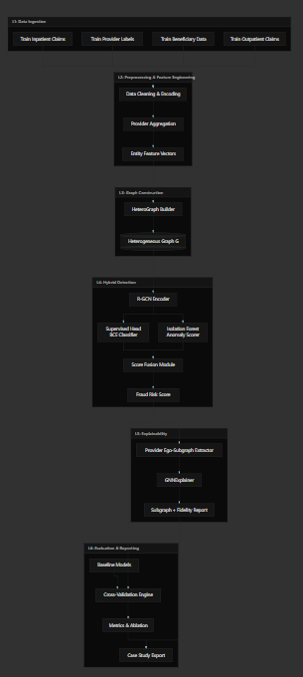

2. Module Descriptions
Module ID | Module Name | Input | Output | Key algorithms | Owner (team)
M1 | Data Loader | 4 train CSV files | Raw DataFrames | pandas | Student A
M2 | Preprocessor | Raw DataFrames | Clean tables + encodings | Label encoding, date parsing, null imputation | Student A
M3 | Feature Aggregator | Claim + beneficiary tables | Provider/beneficiary/physician feature matrices | GroupBy aggregates, top-K diagnosis/procedure counts | Student A
M4 | HeteroGraph Builder | Feature matrices + claim relations | HeteroData (PyG) | Edge list construction, node indexing | Student A
M5 | Graph Validator | HeteroData | Schema stats, leakage checks | Provider-disjoint fold validator | Student A
M6 | R-GCN Encoder | HeteroData, node features | Provider embeddings Z ∈ ℝ^{N×d} | 2-layer HeteroConv + R-GCN | Student B
M7 | Supervised Head | Z_provider | P_fraud ∈ [0,1] | Linear + sigmoid, weighted BCE / focal loss | Student B
M8 | Anomaly Scorer | Z_provider (train non-fraud fit) | S_anomaly ∈ ℝ | sklearn Isolation Forest | Student B
M9 | Score Fusion | P_fraud, S_anomaly | R_final | α-blend or logistic stacker (val-tuned) | Student B
M10 | Baseline Runner | Tabular provider features + centrality | Baseline metrics | CatBoost, RF, RF+centrality | Student A
M11 | CV Orchestrator | Full pipeline | Fold-wise metrics | Stratified 5-fold, provider-disjoint | Student C
M12 | Ego-Subgraph Extractor | G, flagged provider IDs | k-hop induced subgraphs | 2-hop BFS on hetero projection | Student C
M13 | GNNExplainer | Subgraph, trained encoder | Edge/node masks, fidelity | PyG GNNExplainer | Student C
M14 | Report Generator | Metrics + explanations | Figures, tables, JSON case studies | matplotlib, export templates | Student C
Module interaction principles
- M4 → M6 is the only path from raw data to learned representations (no tabular bypass in the main model).
- M7 and M8 are parallel, decoupled heads sharing encoder output — supports ablation.
- M13 reads from frozen M6 weights; no gradient flow during explanation.
- M10 runs independently for benchmark comparison under M11.

3. Data Flow Diagram (DFD)
DFD levels
- Level 0: Context diagram (system vs. external entities)
- Level 1: Major processing stages
Mermaid — DFD Level 0 (Context)

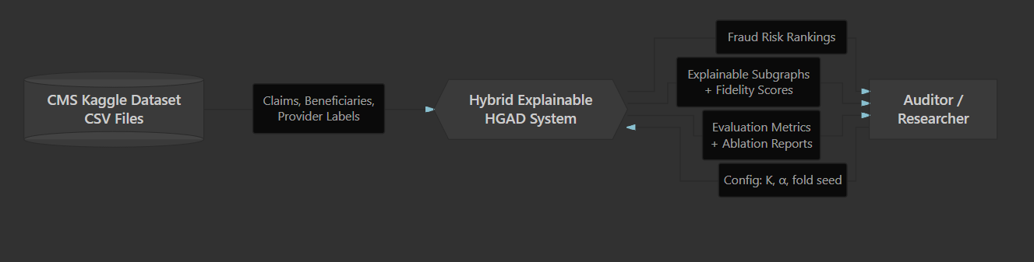
Mermaid — DFD Level 1
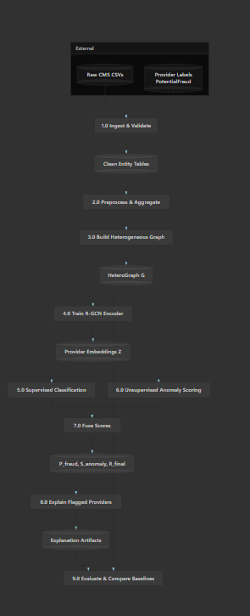

Data store schema (logical)
Store | Contents | Approx. scale (train)
DS1 | providers, beneficiaries, physicians, claims (derived) | 5.4K / 138K / 100K / 558K rows
DS2 | Typed adjacency lists + node feature tensors | ~150K–300K edges (coarsened)
DS3 | Provider embedding matrix | 5,410 × 64
DS4 | Per-provider scores + fold assignments | 5,410 × 5 folds
DS5 | Subgraph masks, fidelity, case metadata | Top-K providers (~50–100)

4. Graph Schema
4.1 Node types
Node type | ID prefix | Count (train, coarsened) | Feature vector (examples)
provider | PRV | 5,410 | total_reimb, claim_count, n_patients, n_physicians, ip_ratio, avg_claim_amt
beneficiary | BEN | ≤138,556 (or top-frequency subset) | age, gender, race, state, chronic_cond_*, annual_reimb
physician | PHY | ≤100,737 (or top-frequency subset) | claim_count, n_providers, n_patients, role_distribution
diagnosis | DX | top-500 ICD codes | code frequency, fraud-rate prior (train only)
Coarsening rule (4GB GPU): Include all providers; cap beneficiaries/physicians at top-N by claim frequency (e.g., N=20K each) or aggregate rare entities into <UNK> nodes.
4.2 Edge types (canonical direction)
Edge type | Source → Target | Derivation | Edge attributes
treated | beneficiary → provider | Claim co-occurrence | claim_count, total_reimb
affiliated_with | physician → provider | Attending physician on claim | co_claim_count, total_reimb
diagnosed | provider → diagnosis | Claims billed by provider with diagnosis | frequency, avg_amount
shares_patient | provider → provider | Shared beneficiary (optional) | shared_patient_count, Jaccard
4.3 Target and masks
Target node type: provider
Target label: PotentialFraud ∈ {0, 1}
Train mask: provider nodes in train fold
Val mask: provider nodes in validation fold
Test mask: provider nodes in test fold (labels withheld on Kaggle test)
Mermaid — Graph Schema (ER-style)
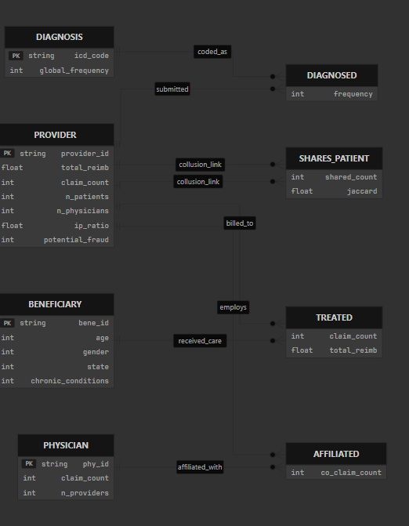
PlantUML — Graph Schema (for draw.io import)
@startuml GraphSchema
skinparam classAttributeIconSize 0
class Provider <<Node>> {
+provider_id: string
+total_reimb: float
+claim_count: int
+n_patients: int
+potential_fraud: {0,1}
}
class Beneficiary <<Node>> {
+bene_id: string
+age: int
+gender: int
+state: int
}
class Physician <<Node>> {
+phy_id: string
+claim_count: int
}
class Diagnosis <<Node>> {
+icd_code: string
+frequency: int
}
Provider "1" -- "0..*" Beneficiary : treated >
Physician "1" -- "0..*" Provider : affiliated_with >
Provider "1" -- "0..*" Diagnosis : diagnosed >
Provider "1" -- "0..*" Provider : shares_patient >
note right of Provider
**Prediction target**
Provider-level fraud label
end note
@enduml

5. UML Component Diagram
@startuml ComponentDiagram
skinparam componentStyle rectangle
package "Data Layer" {
[Data Loader] as DL
[Preprocessor] as PP
[Feature Aggregator] as FA
[Graph Builder] as GB
}
package "Model Layer" {
[R-GCN Encoder] as RGCN
[Supervised Head] as SH
[Isolation Forest] as IF
[Score Fusion] as SF
}
package "Explainability Layer" {
[Ego-Subgraph Extractor] as ESE
[GNNExplainer] as GEX
[Fidelity Evaluator] as FE
}
package "Evaluation Layer" {
[CV Orchestrator] as CV
[Baseline Runner] as BR
[Metrics Reporter] as MR
}
interface "CSV Files" as CSV
interface "Fraud Predictions" as PRED
interface "Explanation Reports" as EXP
interface "Metrics JSON" as MET
CSV --> DL
DL --> PP --> FA --> GB
GB --> RGCN
RGCN --> SH
RGCN --> IF
SH --> SF
IF --> SF
SF --> PRED
SF --> ESE --> GEX --> FE --> EXP
SF --> CV
BR --> CV
CV --> MR --> MET
note bottom of SF
R_final = α·P_fraud + (1-α)·S_anomaly
α tuned on validation fold
end note
@enduml
Component dependencies (textual)
Data Loader → Preprocessor → Feature Aggregator → Graph Builder
Graph Builder → R-GCN Encoder
R-GCN Encoder → {Supervised Head, Isolation Forest}
{Supervised Head, Isolation Forest} → Score Fusion
Score Fusion → {Ego-Subgraph Extractor, CV Orchestrator}
Ego-Subgraph Extractor → GNNExplainer → Fidelity Evaluator
Baseline Runner → CV Orchestrator → Metrics Reporter

6. UML Activity Diagram
Process: End-to-end training and inference for one CV fold.
@startuml ActivityDiagram
start
:Load CMS train CSV files;
:Clean and encode features;
:Aggregate claim stats\nper provider/beneficiary/physician;
:Construct heterogeneous graph G;
:Validate provider-disjoint fold split;
partition "Training Phase" {
:Initialize R-GCN encoder;
repeat
:Sample mini-batch neighborhoods;
:Forward pass → provider embeddings Z;
:Compute weighted BCE loss\non labeled providers;
:Backpropagate and update R-GCN;
repeat while (epochs < E_max?) is (yes)
->no;
:Extract final provider embeddings Z*;
:Fit Isolation Forest on Z*\n(train non-fraud subset);
}
partition "Inference Phase" {
:Compute P_fraud from supervised head;
:Compute S_anomaly from IF;
:Fuse R_final = α·P_fraud + (1-α)·S_anomaly;
}
partition "Explainability Phase" {
if (Provider in top-K flagged?) then (yes)
:Extract 2-hop ego-subgraph;
:Run GNNExplainer;
:Compute explanation fidelity;
:Export subgraph case study;
else (no)
endif
}
:Compute fold metrics\n(AUPRC, F1, Recall, Precision);
:Store results;
stop
@enduml
Mermaid equivalent
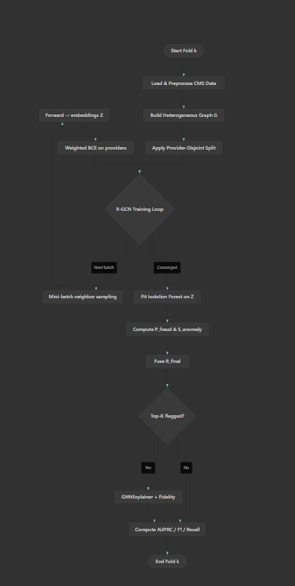

7. Sequence Diagram
Scenario: Inference + explanation for a single flagged provider.
@startuml SequenceDiagram
actor Auditor
participant "API / CLI" as CLI
participant "Graph Store" as GS
participant "R-GCN Encoder" as RGCN
participant "Supervised Head" as SH
participant "Isolation Forest" as IF
participant "Score Fusion" as SF
participant "Ego-Subgraph Extractor" as ESE
participant "GNNExplainer" as GEX
Auditor -> CLI: Request fraud assessment\n(provider_id = PRV51003)
CLI -> GS: Fetch provider node +\n2-hop neighborhood
GS --> CLI: Subgraph G_p
CLI -> RGCN: Encode G_p
RGCN --> CLI: Embedding z_p
par Parallel scoring
CLI -> SH: classify(z_p)
SH --> CLI: P_fraud = 0.91
CLI -> IF: score(z_p)
IF --> CLI: S_anomaly = 0.87
end
CLI -> SF: fuse(P_fraud, S_anomaly)
SF --> CLI: R_final = 0.89\n(FRAUD)
CLI -> ESE: extract_ego(G, PRV51003, hops=2)
ESE --> CLI: Subgraph G_p'
CLI -> GEX: explain(G_p', target=PRV51003)
GEX --> CLI: Edge mask M_e,\nNode mask M_n,\nfidelity = 0.82
CLI --> Auditor: Report:\n- Risk score 0.89\n- Key edges: shared patients,\n physician PHY392922\n- Fidelity 0.82
@enduml
Mermaid equivalent
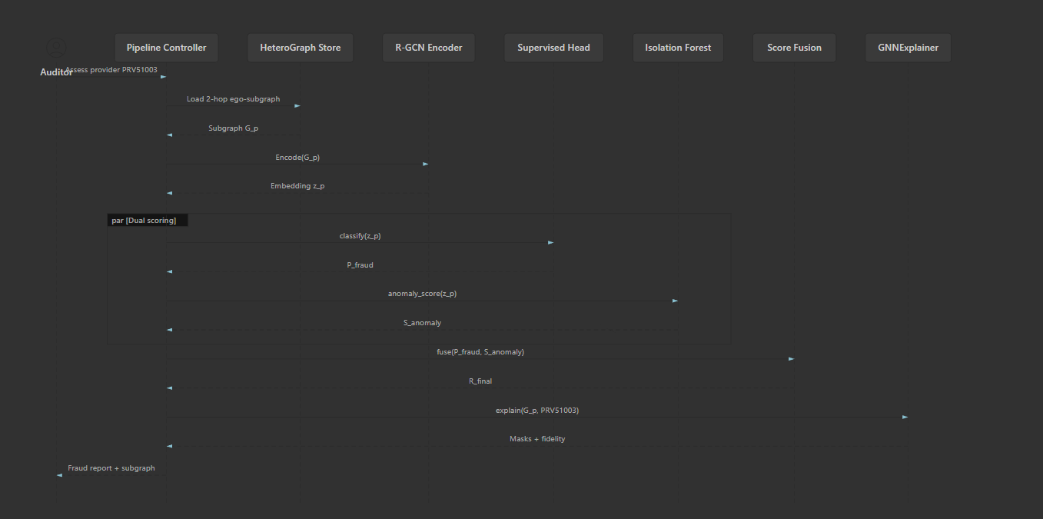

8. Experimental Workflow Diagram
Experimental design summary
Element | Specification
Primary metric | AUPRC (imbalanced provider labels)
Secondary metrics | F1, Recall, Precision, ROC-AUC
CV | 5-fold stratified, provider-disjoint
Fusion tuning | α ∈ {0.1,…,0.9} on validation fold only
Explanation set | Top-50 predicted fraud + 10 FP + 10 TN
Mermaid — Experimental Workflow
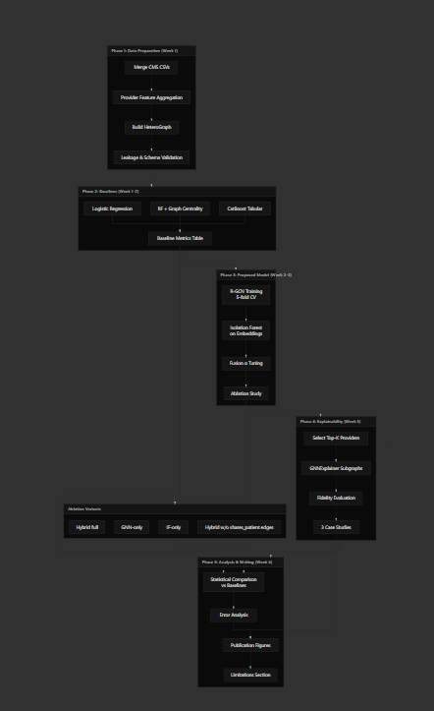

PlantUML — Experimental Workflow (publication variant)
@startuml ExperimentalWorkflow
|Data Prep|
start
:Merge CMS train files;
:Build heterogeneous provider graph;
:Define 5-fold provider-disjoint CV;
|Baselines|
:Train CatBoost on provider aggregates;
:Train RF + centrality features;
:Record baseline AUPRC / F1;
|Proposed Model|
repeat :For each CV fold k;
:Train R-GCN (weighted BCE);
:Fit IF on train embeddings;
:Tune fusion α on val;
:Evaluate on test fold;
repeat while (k < 5?) is (yes)
->no;
|Ablation|
:Run GNN-only, IF-only, Hybrid;
:Run w/ and w/o provider-provider edges;
|Explainability|
:Select top-50 flagged providers;
:Generate GNNExplainer subgraphs;
:Compute fidelity scores;
:Write 3 auditor case studies;
|Analysis|
:Compare Hybrid vs best baseline\n(McNemar / paired t-test);
:Document limitations\n(label noise, single-year data);
stop
@enduml
Results table structure (for paper Table III)
Model | AUPRC ↑ | F1 ↑ | Recall ↑ | Precision ↑ | Train time
Logistic Regression
CatBoost (tabular)
RF + Centrality (Yoo baseline)
R-GCN (supervised only)
IF on embeddings only
Hybrid (R-GCN + IF + fusion)
Hybrid w/o shares_patient edges

Draw.io / Export Notes
Diagram | Recommended tool | Export format
System Architecture (§1) | draw.io | PDF/SVG for paper
Data Flow (§3) | draw.io or Mermaid | SVG
Graph Schema (§4) | draw.io ER template | PNG
UML Component (§5) | PlantUML → draw.io plugin | SVG
UML Activity (§6) | PlantUML | SVG
Sequence (§7) | PlantUML or Mermaid | SVG
Experimental Workflow (§8) | draw.io swimlanes | PDF
Color scheme (publication-ready)
- Data layers: #E3F2FD (light blue)
- Model / detection: #FFF3E0 (light orange)
- Explainability: #E8F5E9 (light green)
- Evaluation: #F3E5F5 (light purple)
- Target node (provider): #FFCDD2 (light red border)

Architecture Decision Records (ADRs)
ADR | Decision | Rationale
ADR-01 | Provider-level prediction | Labels are PotentialFraud per provider
ADR-02 | Coarsened heterograph | 4GB VRAM cannot hold 558K claim nodes
ADR-03 | IF over full GAE | One-month feasibility; IF ablation-compatible
ADR-04 | GNNExplainer over SHAP | Graph-native explanations; literature gap
ADR-05 | Provider-disjoint CV | Prevents leakage via shared beneficiaries
ADR-06 | AUPRC primary metric | 9.35% fraud rate; accuracy misleading
This specification is ready for direct import into draw.io (Mermaid plugin), PlantUML renderers, or thesis methodology chapters. If you want, I can next generate a single consolidated PlantUML file or a draw.io XML skeleton for all eight figures.

